Answers
Task 1
- This image uses four colours so requires 2 bits per pixel. Fill each pixel in the image as a computer using the key.
10 | 10 | 10 | 10 | 10 | 10 | 10 | 10 | 10 | 10 | 10 | 10 | 10 | 10
10 | 00 | 00 | 10 | 00 | 00 | 10 | 00 | 00 | 10 | 00 | 00 | 00 | 10
10 | 00 | 00 | 10 | 00 | 00 | 10 | 00 | 00 | 10 | 00 | 00 | 00 | 10
10 | 10 | 10 | 10 | 10 | 10 | 10 | 10 | 10 | 10 | 10 | 10 | 10 | 10
10 | 00 | 00 | 10 | 00 | 00 | 10 | 00 | 00 | 10 | 00 | 00 | 00 | 10
10 | 00 | 00 | 10 | 00 | 00 | 10 | 00 | 00 | 10 | 00 | 00 | 00 | 10
10 | 00 | 11 | 10 | 10 | 10 | 10 | 10 | 10 | 10 | 10 | 10 | 10 | 10
10 | 11 | 11 | 10 | 10 | 10 | 10 | 10 | 10 | 10 | 10 | 10 | 01 | 01
10 | 10 | 10 | 10 | 11 | 11 | 10 | 10 | 10 | 10 | 11 | 11 | 10 | 10
00 | 00 | 00 | 00 | 11 | 11 | 00 | 00 | 00 | 00 | 11 | 11 | 00 | 00

Key: | 01 | 00 | 11 | 10

- Calculate the file size of the following images:
 | Image Resolution | Number of colours | Colour depth in bits | File size in bits | File size in Bytes
Image 1 | 20 x 20 | 8 | 3 | 1,200 | 150
Image 2 | 10 x 10 | 8 | 3 | 300 | 37.5
Image 3 | 20 x 20 | 4 | 2 | 800 | 100
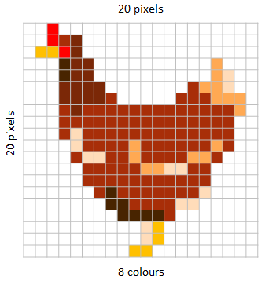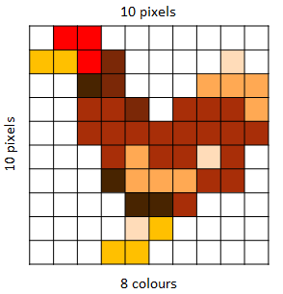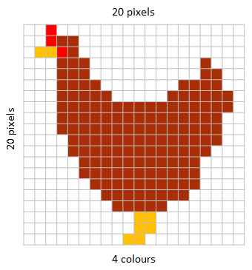

- How does increasing the image resolution affect the file size?
Increasing the resolution will increase the number of pixels used, therefore increasing the file size since each additional pixel will require extra binary data to store its colour value.
- Explain the relationship between image quality and file size.
As the number of pixels increases in the same area, the quality improves, as does the file size. As the number of colours in an image increases, the data required to store a greater number of colours increases, as does the quality and the file size.
Task 2
- Using the following bit pattern, shade in the pixel grid to create a black and white bitmap to create an image where black = 1 and white = 0: 00100 01110 11111 00100 01100

- What is the bit pattern for the following icon image where black = 1 and white = 0?

11000 11111 01011 01001 01111

